**Workflow:**

The assignment is to integrate data from WMS and Tweets text file and display them in Google Earth, the whole process is as follows:

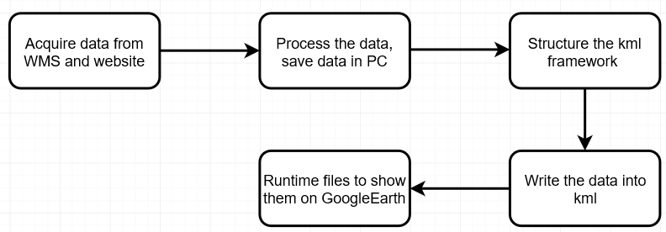

**Modularity:**

For modularity and object-oriented, create three classes. Two are for WMS and Tweet, named “GetWMSImage” and “TweetsWriter”, another one is an executable class which named “GoogleEarthTweetMapper”.

**concrete steps:**

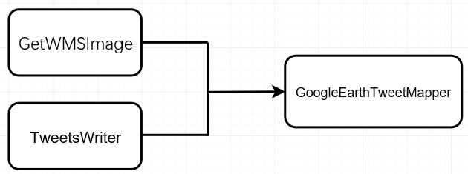

**GetWMSImage Class: define a method to save the map from WMS service and integrate it into a kml file.**

1. set up the WMS request with the URL that is provided.



1. set the properties and layer of the map( is equal to append the HTTP GET parameters

to the URL).

WGS84 is EPSG:4326, format is .png, background is transparent, BBox is boundary of left bottom and right top.

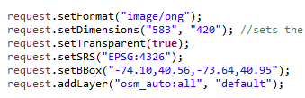

1. get the map with GetMap request and save it as a local image



1. integrate the WMS image into a KML file using a GroundOverlay element. (The bbox coordinate is Xmin, Ymin, Xmax, Ymax) The range is LatLonBox element.

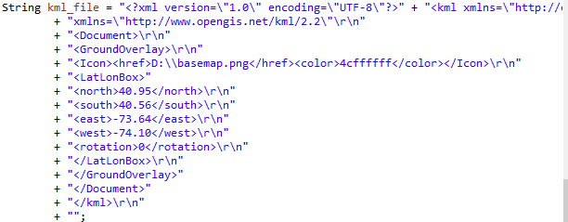

1. create a .kml file and write the string class into the basemap.kml file.

 



**TweetsWriter Class: define a method to read the text file line by line and integrate it into a kml file.**

1. Write the head part of the kml file

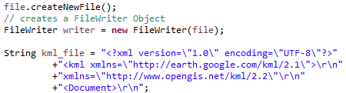

1. Save the csv file from the website, define a file reader and remove the first line of the csv data( because the first line is the attribute name).

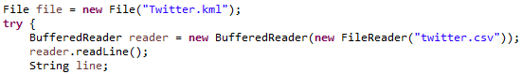

1. Read the csv file line by line and insert coordinates, time and tweets into kml string. (Using split(“;”) to split the string to create array, and then using while loop and array, read one line, write one line.) coordinates, time and tweets are array[1], array[2], array[5], array[6].

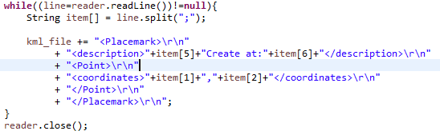

1. Write the end part of the kml string and write kml string into Twitter.kml file.

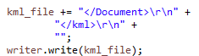

Finish the GetWMSImage Class and TweetsWriter Class, then we need to create the executable class – GoogleEarthTweetMapper to runtime the produce.

**GoogleEarthTweetMapper:**

1. Create an object of GetWMSImage Class and call the getImage() method



1. Create an object of TweetsWriter Class and call the getTweer() method



1. Run the two kml files in Google Earth (previous exercise)

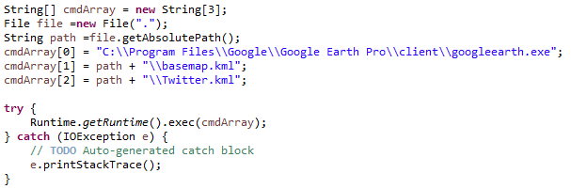

**Result Sample:**

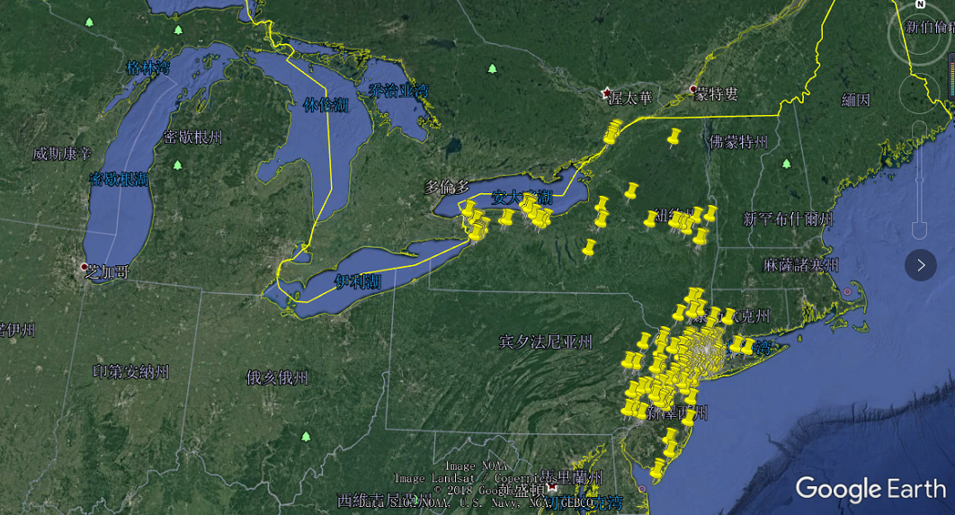 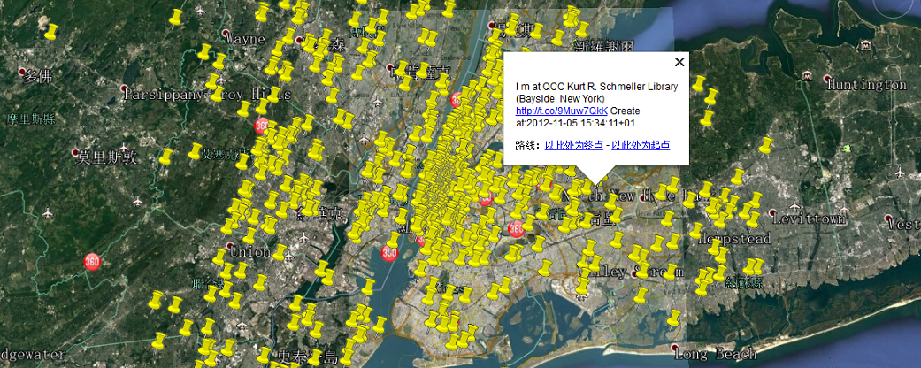

**Reference:**

1.KML Tutorial (very important for me ):  
https://developers.google.cn/kml/documentation/kml_tut?hl=zh-cn

2.GeoTools Tutorial (select package to import, can’t import all package):

http://docs.geotools.org/stable/tutorials/feature/csv2shp.html

3.WMS parameter (learn how to request and response):

https://blog.csdn.net/huyanliang/article/details/17371327

4.Java File Tutorial (learn how to read and write the content of a file)

http://www.runoob.com/java/java-files-io.html